Ronak Jain    ronakdjain91@gmail.com  +91 9664621017    303 Himalaya Building RG Thadani marg Worli Mumbai-18  Objective  To be associated with an organization that gives me scope to update and apply my knowledge & skills in accord with the latest trends in the industry & as well apply my creativity. | Professional Experience | 11 yRS  Mahindra Lifesapces  2021–Current| 4Yrs  Preparing and Coordinating project budgets along with land parcel evaluations.  Poddar Housing  2019–2021| 2Yrs  Preparing, Monitoring & controlling budgets and schedules along with coordination for multiple affordable township projects around Mumbai  Lodha Group  2016 –2019 | 3Yrs  Having a Role of handling contractual claims and preparing and tracking of cost to completion for South Mumbai Projects.  Lodha Group  2015 –2016 | 1Yr  Preparing of BOQ for civil package related items along with monitoring of variation request raised by contractor.  Gammon iNDIA IMITED  2012 –2013| 1.0Yrs  Site Execution and Subcontractor billing  Software Competency  SAP (ERP)  Farvision ERP  CAD  Oracle-Primavera P6  MS Excel (VBA)  MS Word  MS Projects  Google App Scripts

ACADEMIC PROFILE

Degree | Institute/School | University/Board | Result | Year
REUIM | National Institute Of Construction Management And Research, Pune | National Institute Of Construction Management Research, Pune | 8.51 (CPI) | Mar, 2015
B.Tech.(Civil) | Veermata Jijabai Technological Institute | Mumbai University | 6.9  (CPI) | 2012
HSC | Wilson College | Maharashtra Board | 85.17% | 2008
SSC | Dr Antonio Da Silva High School | Maharashtra Board | 77.33% | 2006

Achievements & Accolades
- Created and monitored budgets for township Projects amounting to 775 and 575 Cr of 32Lakh and 23Lakh Sqft Respectively
- Successfully migrated to and implemented Farvision ERP along with providing and implementing constructive ideas and for better controls and forecasts.
- Awarded employee of the month for the month of March 2018 for swiftly and accurately completing CTC report for Car Park
- Awarded Spot Award for segregating and analyzing 4000 orders amounting to 70Cr data ageing to 9 Years
- Saved 25 Lakhs on replacing back-filing vendor with efficient vendor.
- Created cost to completion reports for world Crest, World One & Government and Residential Car Park for World Towers Project.
- Created CTC reports for Venezia and Washington house projects.
- Forecasted Civil costs for entire residential buildings in project Kolshet consisting of 50 buildings
- Made BOQs of varied civil related works all across companies work

Technical Exposure & cO CURICULAR aCTIVITIES
- Attended conference on land acquisition act at ILS (Indian Law Society's Law College) Pune.
- Participated in Seismic Design Competition in EERI (Earthquake Engineering Research Institute), Memphis, USA.
- Design coordinator in “applicable auto parking concept”
- Participated In “Shastra” complete building design competition-IIT Chennai.

Projects, Roles & Responsiblities
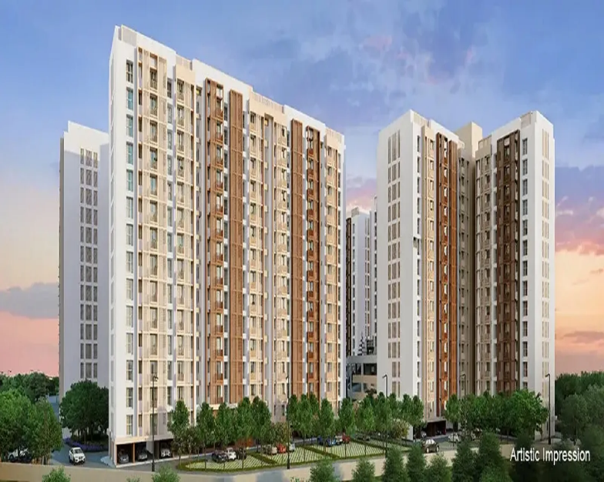



Mahindra Nestalgia-450 Cr

Mahindra Happinest Kalyan 2 – 480 Cr

Key Responsiblities Undertaken

Costing and Budgeting Team
- Preparation of Construction Budget Estimate at bussiness case level at time of land acquisitions.
- Preparation of Construction budgets during pre construction period at multiple stages like CD,SD, DD and GFC
- Reviewing and facilitating ,creations of CTC budgets during time of cosntruction of projects.
- Creating and providing the BOQs for complete project along with complete support to contracts team at time of tendering
- Creating of auto budgeting tool which helps in creating and sampling of project concept level descisons in terms of cost.

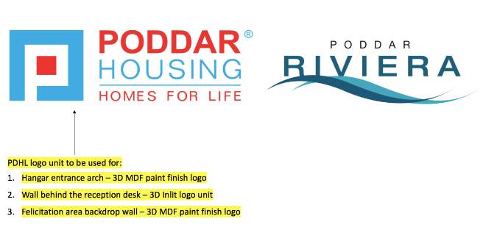



Poddar Annatah Rivieria-575 Cr

Poddar Wondercity-775 Cr

Key Responsiblities Undertaken

Project Controls Team

- Preparation of budgets for all the upcoming projects with concept level details
- Monitoring controlling budgets in ERP via modes of material and BOQ attachments.
- Migrating , Implentating and monitoring to Farvision ERP and playing role of core Team member
- Preparing ,implementing and automating BOQ and Material attachment processes and systems in the organizations.




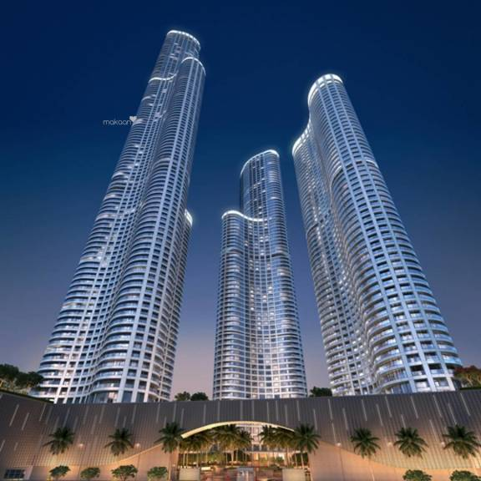

The World Towers-4000 Cr

Washington House Project-300 Cr

Key Responsiblities Undertaken

Commercial Team
- Preparation & tracking of Cost to Completion for South Mumbai Projects.
- Updating and tracking trade-wise budget on quantity basis and ensuring timely resolution of budget errors within lead time
- Preparing of Monthly Cost Report including yearly/Quarterly/Monthly forecast.
- Providing all type of cost related MIS to higher management as and when required.

- Processing claims variations along with co-ordination with Design and Procurement.
- Preparing Rate master for reference used over entire projects across the firm
- Certification of RA bill and posting of SES
- Sourcing of vendors & empaneling them under relevant categories.

Project Controls and Audit Team

- Preparing Costed BOQ by applying standard specifications, units and rates based on rate master for standard items
- Preparing Rate master of package civil for reference used over entire projects across the firm
- Forecasting material quantity based on measurement sheets with approved wastage and doing attachments in SAP with correct attributes.
- Creating bench-marking of rates on various items (materials and services) across company's projects
- Preparing Budget summary based on bench-marked data and approximate quantities or costed BOQ where applicable

LODHA Venezia-400 Cr
- Regular Cost to Complete exercise of various projects by reviewing issued Work orders and updating budget
- Doing Value engineering over the BOQ that are awarded or to be awarded.
- Trend analysis of work order and material rates based on contracts awarded in past 2 years to ascertain the fluctuations in rates for various items and to establish the percentage inflation
- Accurate quantity surveying and estimation

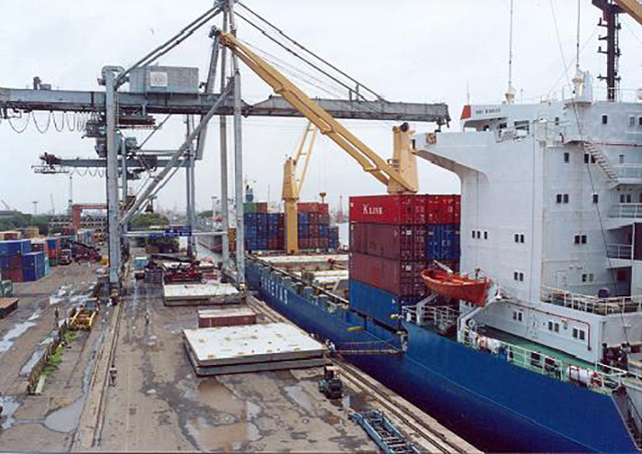

mbpt oFFSHORE CONTAINER TERMINAL-4000 Cr

Key Responsiblities Undertaken
- Planning of activities at site.
- Quantity estimation of buildings.
- Subcontractor billing using citrix and reviewing of client billing activities.
- Preparing MPR and DPR
- Estimating Material, Manpower and Machine Requirement at site.
- Preparing method statements.
- Supervision of civil activities on site

